# Multilevel Truncated Negative Binomial Model Results

## Fixed Effects Coefficients

| Estimate | Std. Error | z value | P-value | Variable |
| --- | --- | --- | --- | --- |
| 0.5396 | 0.1555 | 3.4688 | 0.0005 | (Intercept) |
| 0.0008 | 0.0004 | 1.9043 | 0.0569 | import_from_slu_log |
| 0.0071 | 0.0001 | 51.8477 | 0.0000 | age |
| 0.0894 | 0.0196 | 4.5605 | 0.0000 | distance_miles_log |
| -0.0326 | 0.0029 | -11.3478 | 0.0000 | state_unemployment |
| -0.0011 | 0.0001 | -7.8739 | 0.0000 | immigrant_density |
| 0.0093 | 0.0036 | 2.6177 | 0.0089 | sex_enc1 |
| 0.0209 | 0.0121 | 1.7296 | 0.0837 | marital_status_enc1 |
| 0.0314 | 0.0044 | 7.1826 | 0.0000 | marital_status_enc2 |
| 0.1182 | 0.0203 | 5.8101 | 0.0000 | employment_status_enc1 |
| -0.0535 | 0.0284 | -1.8862 | 0.0593 | employment_status_enc2 |
| 0.4007 | 0.0233 | 17.2174 | 0.0000 | purpose_simple2 |
| 0.1027 | 0.2734 | 0.3757 | 0.7072 | purpose_simple3 |
| 0.3776 | 0.0294 | 12.8275 | 0.0000 | purpose_simple4 |
| 0.2733 | 0.0227 | 12.0229 | 0.0000 | purpose_simple5 |
| 0.1626 | 0.0092 | 17.6526 | 0.0000 | accomd_type_enc1 |
| 0.3141 | 0.0051 | 61.5053 | 0.0000 | accomd_type_enc2 |
| 0.1102 | 0.0053 | 20.8853 | 0.0000 | season_enc1 |
| 0.0838 | 0.0053 | 15.9104 | 0.0000 | season_enc2 |
| 0.1632 | 0.0054 | 30.2956 | 0.0000 | season_enc3 |
| -0.0008 | 0.0077 | -0.1094 | 0.9129 | region_census2 |
| -0.0299 | 0.0086 | -3.4915 | 0.0005 | region_census3 |
| 0.0631 | 0.0117 | 5.4078 | 0.0000 | region_census5 |
| 0.4203 | 0.0202 | 20.8332 | 0.0000 | tourist_type_enc1 |
| 0.0260 | 0.0099 | 2.6408 | 0.0083 | tourist_type_enc2 |

## Incident Rate Ratios (IRR) for Fixed Effects

Incident Rate Ratios for Fixed Effects

| Variable | IRR | Lower CI | Upper CI | P-value |
| --- | --- | --- | --- | --- |
| (Intercept) | 1.7152 | 1.2645 | 2.3266 | 0.0005 |
| import_from_slu_log | 1.0008 | 1.0000 | 1.0016 | 0.0569 |
| age | 1.0072 | 1.0069 | 1.0074 | 0.0000 |
| distance_miles_log | 1.0935 | 1.0523 | 1.1363 | 0.0000 |
| state_unemployment | 0.9680 | 0.9625 | 0.9734 | 0.0000 |
| immigrant_density | 0.9989 | 0.9986 | 0.9992 | 0.0000 |
| sex_enc1 | 1.0094 | 1.0023 | 1.0165 | 0.0089 |
| marital_status_enc1 | 1.0212 | 0.9972 | 1.0457 | 0.0837 |
| marital_status_enc2 | 1.0319 | 1.0231 | 1.0407 | 0.0000 |
| employment_status_enc1 | 1.1254 | 1.0815 | 1.1712 | 0.0000 |
| employment_status_enc2 | 0.9479 | 0.8966 | 1.0021 | 0.0593 |
| purpose_simple2 | 1.4928 | 1.4262 | 1.5625 | 0.0000 |
| purpose_simple3 | 1.1082 | 0.6484 | 1.8940 | 0.7072 |
| purpose_simple4 | 1.4588 | 1.3770 | 1.5454 | 0.0000 |
| purpose_simple5 | 1.3143 | 1.2570 | 1.3741 | 0.0000 |
| accomd_type_enc1 | 1.1765 | 1.1555 | 1.1980 | 0.0000 |
| accomd_type_enc2 | 1.3691 | 1.3554 | 1.3828 | 0.0000 |
| season_enc1 | 1.1165 | 1.1050 | 1.1281 | 0.0000 |
| season_enc2 | 1.0874 | 1.0762 | 1.0986 | 0.0000 |
| season_enc3 | 1.1773 | 1.1649 | 1.1898 | 0.0000 |
| region_census2 | 0.9992 | 0.9842 | 1.0144 | 0.9129 |
| region_census3 | 0.9706 | 0.9544 | 0.9870 | 0.0005 |
| region_census5 | 1.0652 | 1.0411 | 1.0898 | 0.0000 |
| tourist_type_enc1 | 1.5224 | 1.4634 | 1.5838 | 0.0000 |
| tourist_type_enc2 | 1.0264 | 1.0067 | 1.0464 | 0.0083 |

## Random Effects Variance Components

No random effect variance estimated for region_climate.

## Variance Inflation Factor (VIF)

VIF Values (Note: VIF > 5 may indicate multicollinearity)

| Variable | VIF |
| --- | --- |
| Predictor 1 | 1.40 |
| Predictor 2 | 1.37 |
| Predictor 3 | 4.63 |
| Predictor 4 | 1.27 |
| Predictor 5 | 1.82 |
| Predictor 6 | 1.02 |
| Predictor 7 | 1.23 |
| Predictor 8 | 1.01 |
| Predictor 9 | 1.33 |
| Predictor 10 | 1.10 |
| Predictor 11 | 1.05 |
| Predictor 12 | 7.69 |
| Predictor 13 | 1.07 |

## Model Comparison (Truncated vs Non-truncated)

ANOVA Model Comparison Results

| Df | AIC | BIC | logLik | deviance | Chisq | Chi Df | Pr(>Chisq) |
| --- | --- | --- | --- | --- | --- | --- | --- |
| 27 | 742,293.7 | 742,559.3 | -371,119.9 | 742,239.7 |  |  |  |
| 27 | 747,936.7 | 748,202.2 | -373,941.3 | 747,882.7 | 0 | 0 | 1 |

## Model Fit Statistics

| Statistic | Value |
| --- | --- |
| AIC | 742,293.7 |
| BIC | 742,559.3 |
| Log-likelihood | -371,119.9 |

## Predicted vs Observed Length of Stay

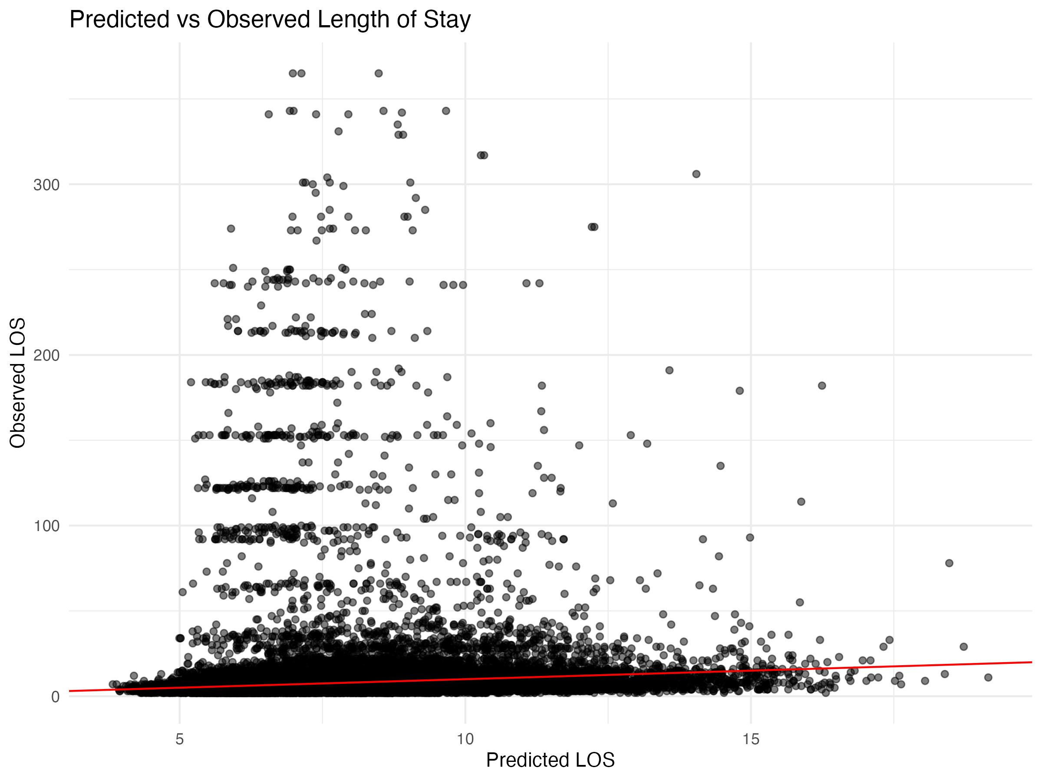

## Diagnostic Plots

### DHARMa Residuals

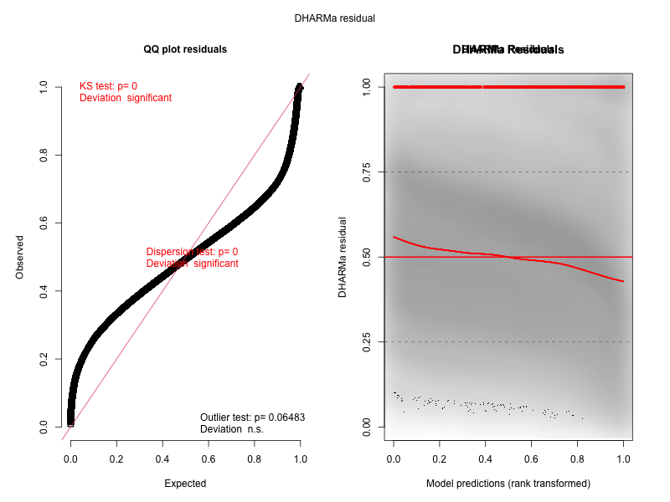

### Residuals by State

